**Laporan Tugas 1 Pengelolaan Basis Data**

“Basis Data Perpustakaan”



Disusun oleh:

170411100097 Mochamad Salim Ubaidillah

170411100034 Moch Maqyn Fauzi

180411100046 Asfani Rahmatullah

Pengelolaan Basis Data Kelas E

Dosen Pengampu: Dr. Arif Muntasa, S.Si, M.T.

Program Studi S1 Teknik Informatika

Fakultas Teknik

Universitas Trunojoyo Madura

2020

**Daftar Isi**

Daftar Isi 2

1. Menggunakan minimal 2 form

Form 1 Peminjaman 3

Form 2 Pengembalian 3

1. ER-Model per Form

ER-Model form 1 4

ER-Model form 2 4

1. ER-Model Gabungan 5
2. Atruktur Model 6
3. Normalisasi 7
4. Power Designer

CDM 9

LDM 10

PDM 11

1. Mengenete pdm ke dbms mysql 12
2. Run script di mysql 15

Daftar Pustaka 17

1. Menggunakan minimal 2 form

Form 1 Peminjaman

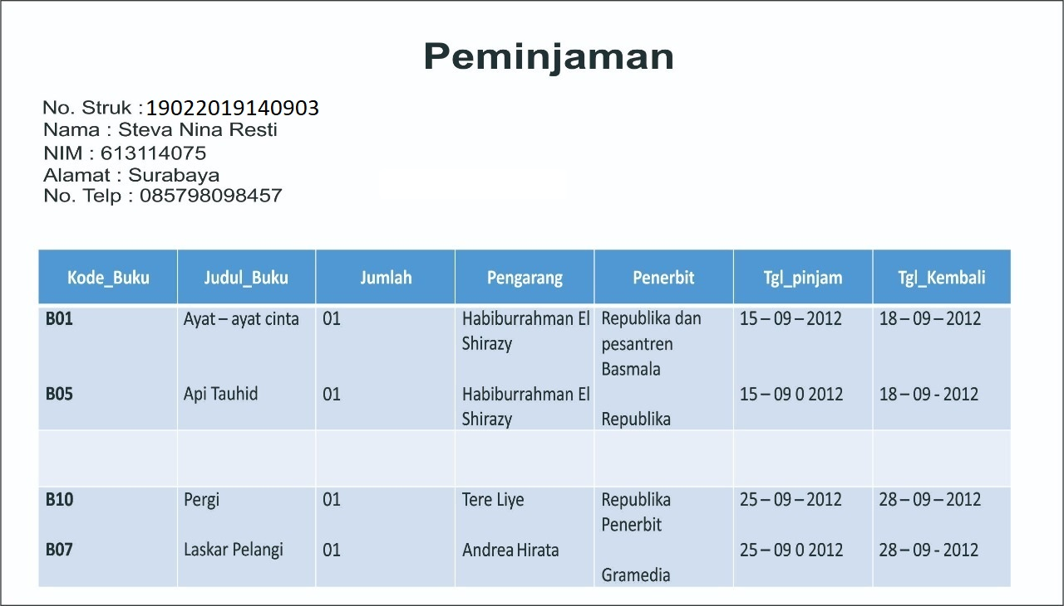

Form 2 Pengembalian

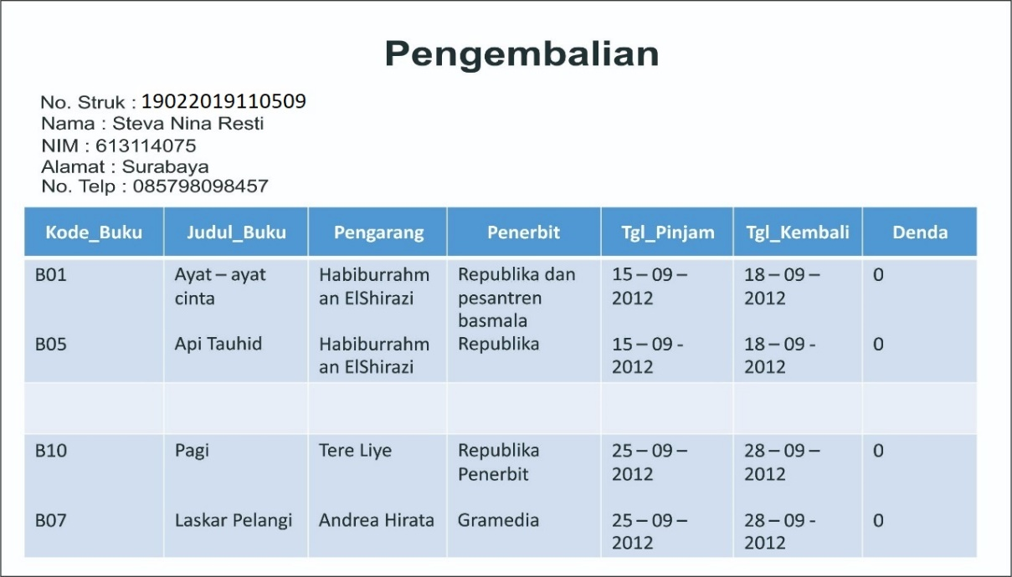

1. ER-Model per Form

ER-Model form 1

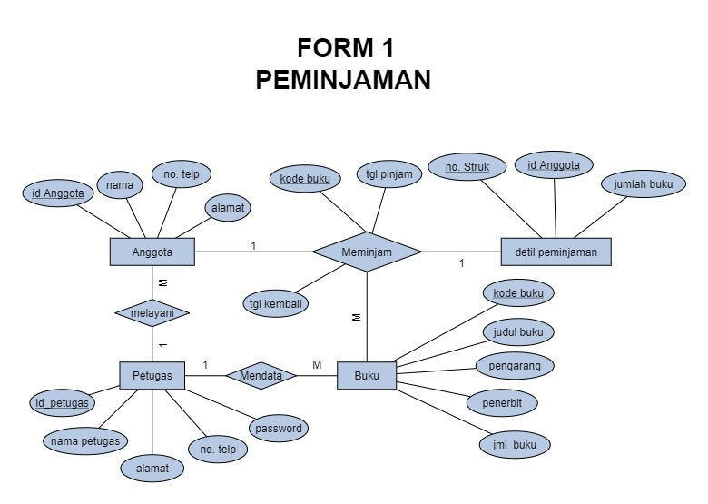

ER-Model form 2

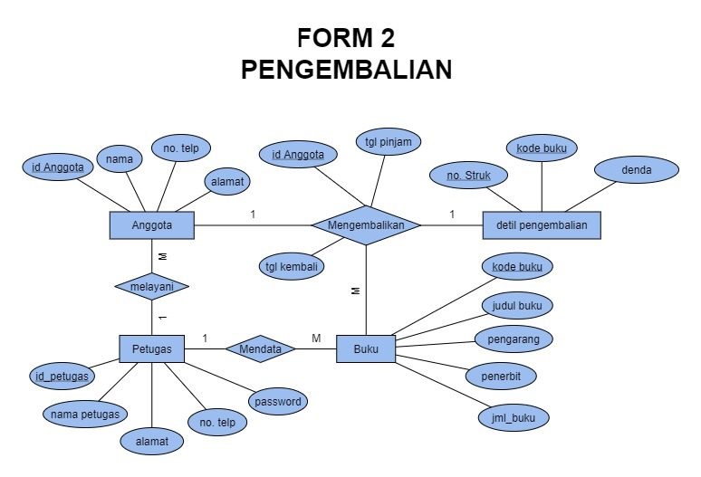

1. ER-Model Gabungan

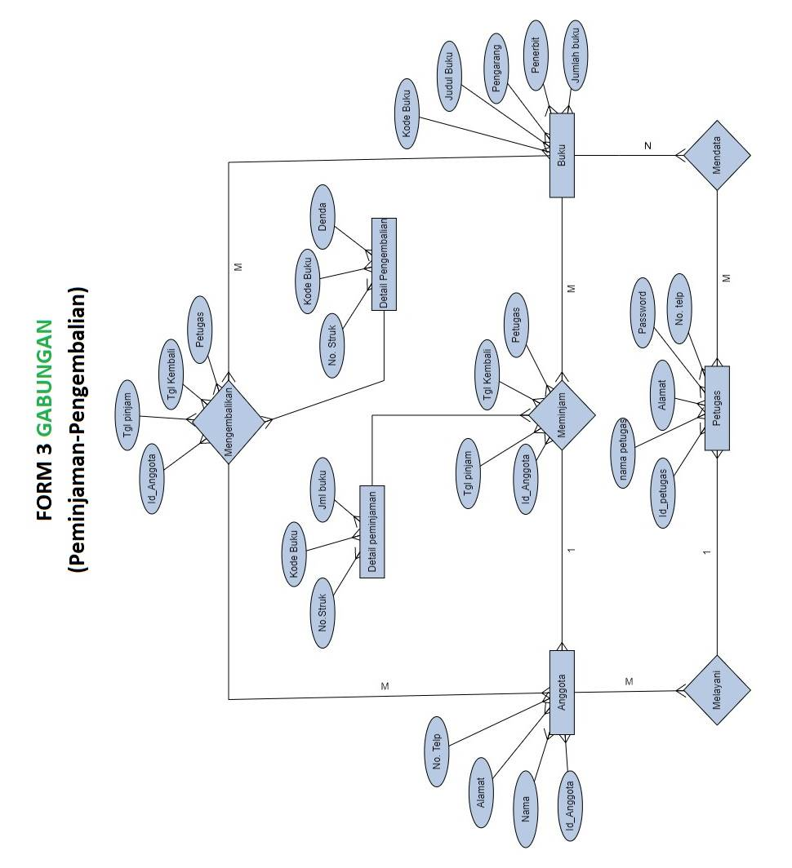

1. Atruktur Model

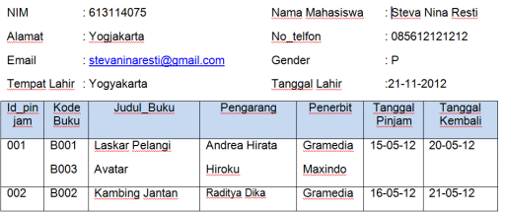

1. Normalisasi

Unormalized Form (Bentuk tidak normal)

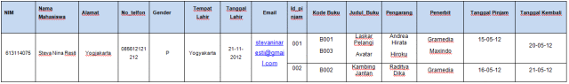

1 NF (Normalisasi Form bentuk 1)

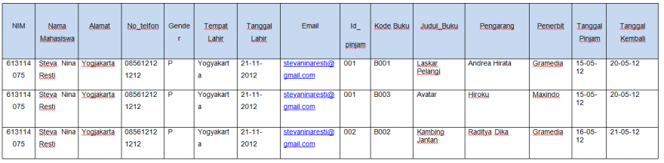

2 NF (Normalisasi Form bentuk 2)

Tabel Mahasiswa

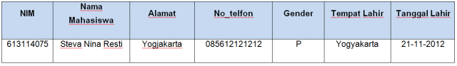

Tabel Peminjaman

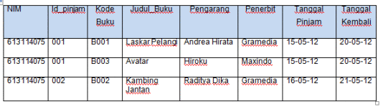

3 NF (Normalisasi Form bentuk 3)

Tabel Buku

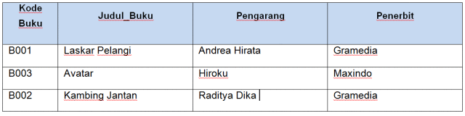

Tabel Dipinjam

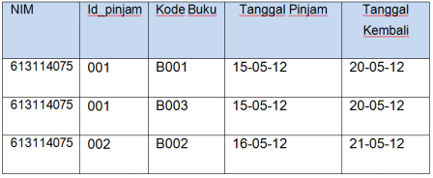

BCNF (Bentuk Normal Boyce-Code)

Menghilangkan ketergantungan multivalue

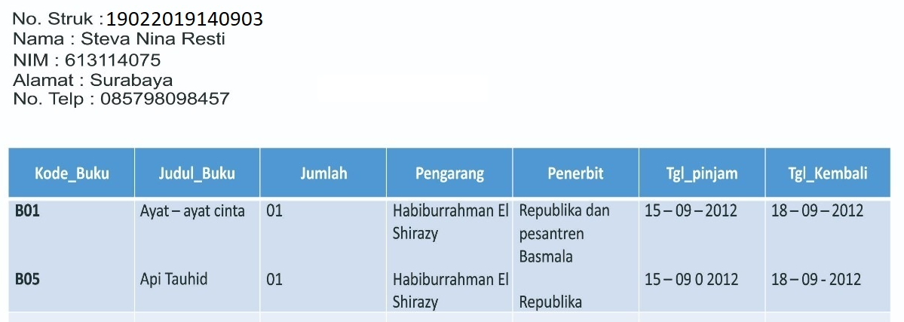

4 NF (Normalisasi Form bentuk 4)

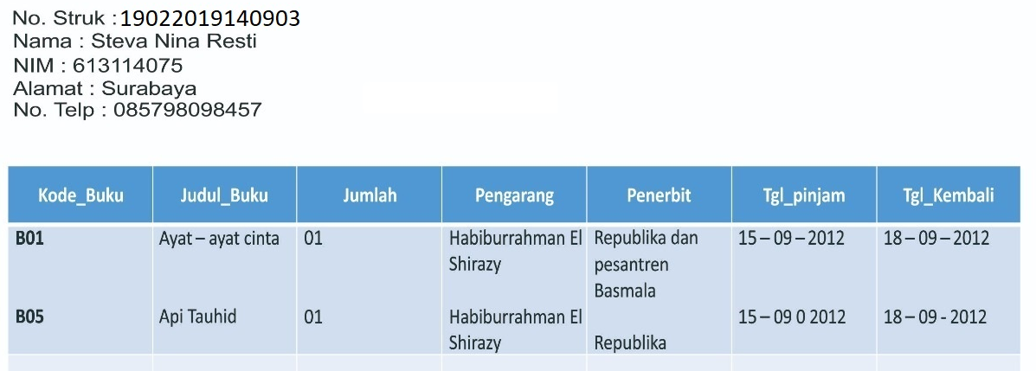

1. Power Designer

CDM

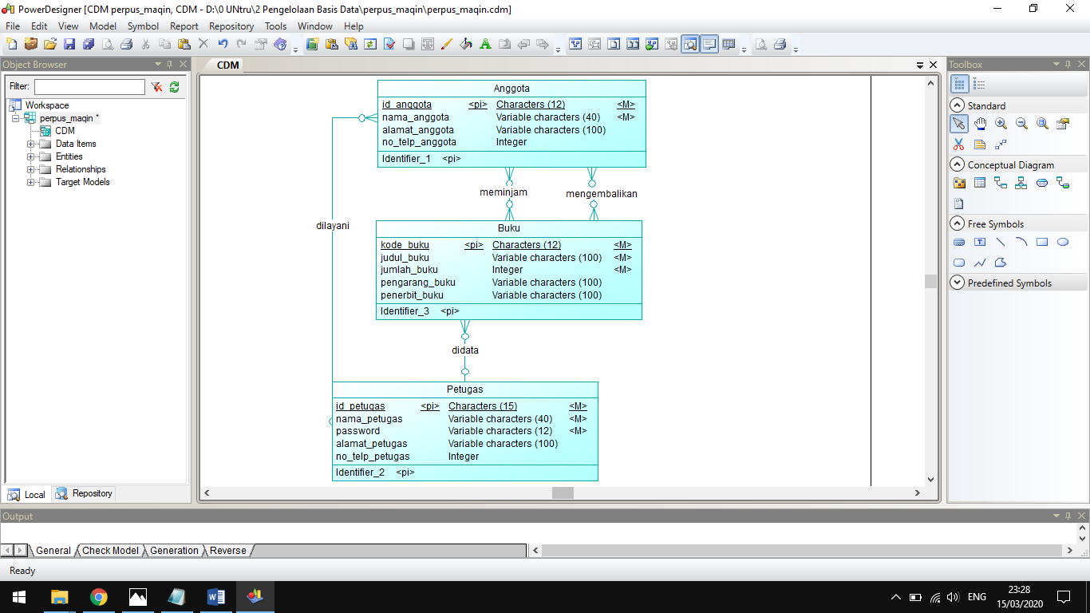

LDM

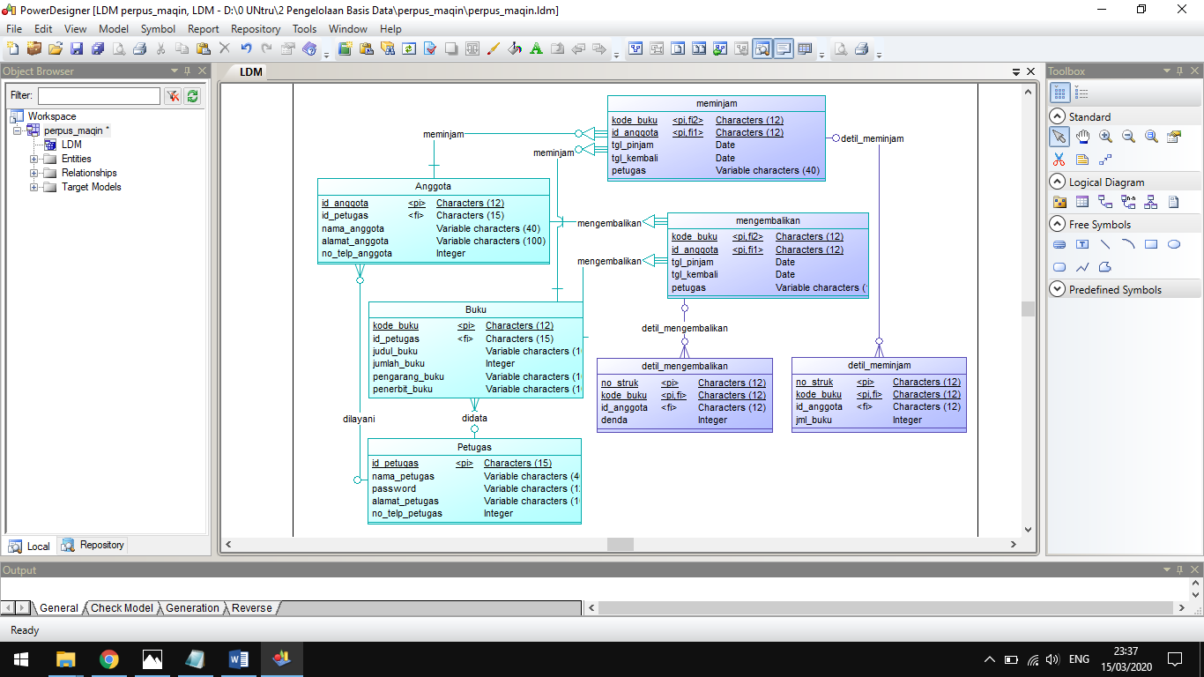

PDM

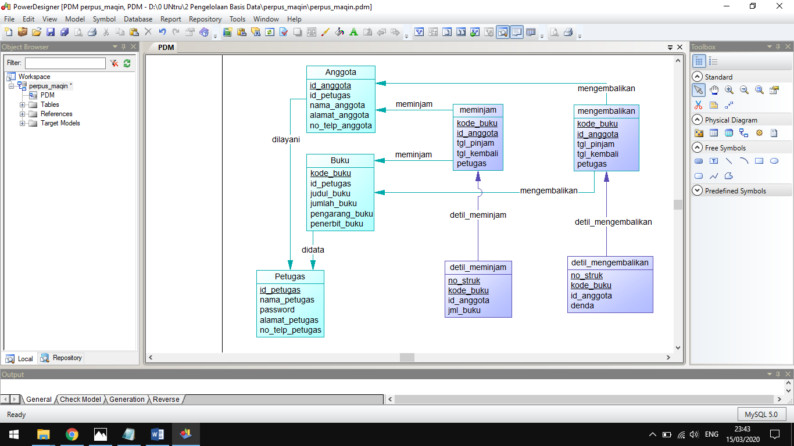

1. Mengenete pdm ke dbms mysql

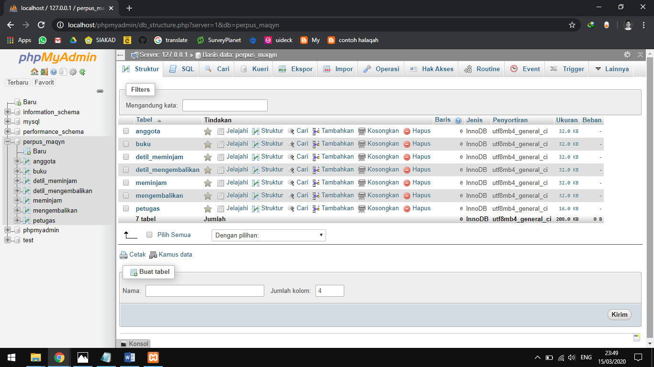

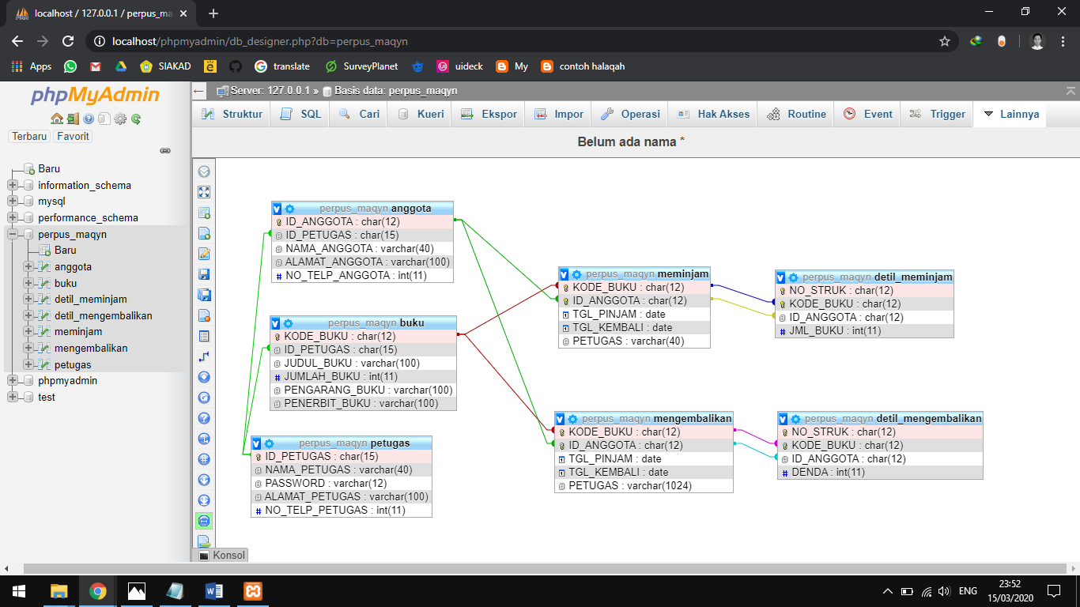

/*==============================================================*/

/* DBMS name: MySQL 5.0 */

/* Created on: 12/03/2020 21:43:47 */

/*==============================================================*/

drop table if exists ANGGOTA;

drop table if exists BUKU;

drop table if exists DETIL_MEMINJAM;

drop table if exists DETIL_MENGEMBALIKAN;

drop table if exists MEMINJAM;

drop table if exists MENGEMBALIKAN;

drop table if exists PETUGAS;

/*==============================================================*/

/* Table: ANGGOTA */

/*==============================================================*/

create table ANGGOTA

(

ID_ANGGOTA char(12) not null,

ID_PETUGAS char(15),

NAMA_ANGGOTA varchar(40) not null,

ALAMAT_ANGGOTA varchar(100),

NO_TELP_ANGGOTA int,

primary key (ID_ANGGOTA)

);

alter table ANGGOTA comment 'tabel ini berisi identitas anggota perpustakaan';

/*==============================================================*/

/* Table: BUKU */

/*==============================================================*/

create table BUKU

(

KODE_BUKU char(12) not null,

ID_PETUGAS char(15),

JUDUL_BUKU varchar(100) not null,

JUMLAH_BUKU int not null,

PENGARANG_BUKU varchar(100),

PENERBIT_BUKU varchar(100),

primary key (KODE_BUKU)

);

/*==============================================================*/

/* Table: DETIL_MEMINJAM */

/*==============================================================*/

create table DETIL_MEMINJAM

(

NO_STRUK char(12) not null,

KODE_BUKU char(12) not null,

ID_ANGGOTA char(12),

JML_BUKU int not null,

primary key (NO_STRUK, KODE_BUKU)

);

/*==============================================================*/

/* Table: DETIL_MENGEMBALIKAN */

/*==============================================================*/

create table DETIL_MENGEMBALIKAN

(

NO_STRUK char(12) not null,

KODE_BUKU char(12) not null,

ID_ANGGOTA char(12),

DENDA int,

primary key (NO_STRUK, KODE_BUKU)

);

/*==============================================================*/

/* Table: MEMINJAM */

/*==============================================================*/

create table MEMINJAM

(

KODE_BUKU char(12) not null,

ID_ANGGOTA char(12) not null,

TGL_PINJAM date not null,

TGL_KEMBALI date not null,

PETUGAS varchar(40) not null,

primary key (KODE_BUKU, ID_ANGGOTA)

);

/*==============================================================*/

/* Table: MENGEMBALIKAN */

/*==============================================================*/

create table MENGEMBALIKAN

(

KODE_BUKU char(12) not null,

ID_ANGGOTA char(12) not null,

TGL_PINJAM date not null,

TGL_KEMBALI date not null,

PETUGAS varchar(1024) not null,

primary key (KODE_BUKU, ID_ANGGOTA)

);

/*==============================================================*/

/* Table: PETUGAS */

/*==============================================================*/

create table PETUGAS

(

ID_PETUGAS char(15) not null,

NAMA_PETUGAS varchar(40) not null,

PASSWORD varchar(12) not null,

ALAMAT_PETUGAS varchar(100),

NO_TELP_PETUGAS int,

primary key (ID_PETUGAS)

);

alter table ANGGOTA add constraint FK_DILAYANI foreign key (ID_PETUGAS)

references PETUGAS (ID_PETUGAS) on delete restrict on update cascade;

alter table BUKU add constraint FK_DIDATA foreign key (ID_PETUGAS)

references PETUGAS (ID_PETUGAS) on delete restrict on update cascade;

alter table DETIL_MEMINJAM add constraint FK_RELATIONSHIP_7 foreign key (KODE_BUKU, ID_ANGGOTA)

references MEMINJAM (KODE_BUKU, ID_ANGGOTA) on delete restrict on update cascade;

alter table DETIL_MENGEMBALIKAN add constraint FK_DETIL_MENGEMBALIKAN foreign key (KODE_BUKU, ID_ANGGOTA)

references MENGEMBALIKAN (KODE_BUKU, ID_ANGGOTA) on delete restrict on update cascade;

alter table MEMINJAM add constraint FK_MEMINJAM foreign key (KODE_BUKU)

references BUKU (KODE_BUKU) on delete restrict on update cascade;

alter table MEMINJAM add constraint FK_MEMINJAM2 foreign key (ID_ANGGOTA)

references ANGGOTA (ID_ANGGOTA) on delete restrict on update cascade;

alter table MENGEMBALIKAN add constraint FK_MENGEMBALIKAN foreign key (KODE_BUKU)

references BUKU (KODE_BUKU) on delete restrict on update cascade;

alter table MENGEMBALIKAN add constraint FK_MENGEMBALIKAN2 foreign key (ID_ANGGOTA)

references ANGGOTA (ID_ANGGOTA) on delete restrict on update cascade;

drop table if exists MENGEMBALIKAN;

drop table if exists PETUGAS;

/*==============================================================*/

/* Table: ANGGOTA */

/*==============================================================*/

create table ANGGOTA

(

ID_ANGGOTA char(12) not null,

ID_PETUGAS char(15),

NAMA_ANGGOTA varchar(40) not null,

ALAMAT_ANGGOTA varchar(100),

NO_TELP_ANGGOTA int,

primary key (ID_ANGGOTA)

);

alter table ANGGOTA comment 'tabel ini berisi identitas anggota perpustakaan';

/*==============================================================*/

/* Table: BUKU */

/*==============================================================*/

create table BUKU

(

KODE_BUKU char(12) not null,

ID_PETUGAS char(15),

JUDUL_BUKU varchar(100) not null,

JUMLAH_BUKU int not null,

PENGARANG_BUKU varchar(100),

PENERBIT_BUKU varchar(100),

primary key (KODE_BUKU)

);

/*==============================================================*/

/* Table: DETIL_MEMINJAM */

/*==============================================================*/

create table DETIL_MEMINJAM

(

NO_STRUK char(12) not null,

KODE_BUKU char(12) not null,

ID_ANGGOTA char(12),

JML_BUKU int not null,

primary key (NO_STRUK, KODE_BUKU)

);

/*==============================================================*/

/* Table: DETIL_MENGEMBALIKAN */

/*==============================================================*/

create table DETIL_MENGEMBALIKAN

(

NO_STRUK char(12) not null,

KODE_BUKU char(12) not null,

ID_ANGGOTA char(12),

DENDA int,

primary key (NO_STRUK, KODE_BUKU)

);

/*==============================================================*/

/* Table: MEMINJAM */

/*==============================================================*/

create table MEMINJAM

(

KODE_BUKU char(12) not null,

ID_ANGGOTA char(12) not null,

TGL_PINJAM date not null,

TGL_KEMBALI date not null,

PETUGAS varchar(40) not null,

primary key (KODE_BUKU, ID_ANGGOTA)

);

/*==============================================================*/

/* Table: MENGEMBALIKAN */

/*==============================================================*/

create table MENGEMBALIKAN

(

KODE_BUKU char(12) not null,

ID_ANGGOTA char(12) not null,

TGL_PINJAM date not null,

TGL_KEMBALI date not null,

PETUGAS varchar(1024) not null,

primary key (KODE_BUKU, ID_ANGGOTA)

);

/*==============================================================*/

/* Table: PETUGAS */

/*==============================================================*/

create table PETUGAS

(

ID_PETUGAS char(15) not null,

NAMA_PETUGAS varchar(40) not null,

PASSWORD varchar(12) not null,

ALAMAT_PETUGAS varchar(100),

NO_TELP_PETUGAS int,

primary key (ID_PETUGAS)

);

alter table ANGGOTA add constraint FK_DILAYANI foreign key (ID_PETUGAS)

references PETUGAS (ID_PETUGAS) on delete restrict on update cascade;

alter table BUKU add constraint FK_DIDATA foreign key (ID_PETUGAS)

references PETUGAS (ID_PETUGAS) on delete restrict on update cascade;

alter table DETIL_MEMINJAM add constraint FK_RELATIONSHIP_7 foreign key (KODE_BUKU, ID_ANGGOTA)

references MEMINJAM (KODE_BUKU, ID_ANGGOTA) on delete restrict on update cascade;

alter table DETIL_MENGEMBALIKAN add constraint FK_DETIL_MENGEMBALIKAN foreign key (KODE_BUKU, ID_ANGGOTA)

references MENGEMBALIKAN (KODE_BUKU, ID_ANGGOTA) on delete restrict on update cascade;

alter table MEMINJAM add constraint FK_MEMINJAM foreign key (KODE_BUKU)

references BUKU (KODE_BUKU) on delete restrict on update cascade;

alter table MEMINJAM add constraint FK_MEMINJAM2 foreign key (ID_ANGGOTA)

references ANGGOTA (ID_ANGGOTA) on delete restrict on update cascade;

alter table MENGEMBALIKAN add constraint FK_MENGEMBALIKAN foreign key (KODE_BUKU)

references BUKU (KODE_BUKU) on delete restrict on update cascade;

alter table MENGEMBALIKAN add constraint FK_MENGEMBALIKAN2 foreign key (ID_ANGGOTA)

references ANGGOTA (ID_ANGGOTA) on delete restrict on update cascade;

(

KODE_BUKU char(12) not null,

ID_ANGGOTA char(12) not null,

TGL_PINJAM date not null,

TGL_KEMBALI date not null,

PETUGAS varchar(40) not null,

primary key (KODE_BUKU, ID_ANGGOTA)

);

/*==============================================================*/

/* Table: MENGEMBALIKAN */

/*==============================================================*/

create table MENGEMBALIKAN

(

KODE_BUKU char(12) not null,

ID_ANGGOTA char(12) not null,

TGL_PINJAM date not null,

TGL_KEMBALI date not null,

PETUGAS varchar(1024) not null,

primary key (KODE_BUKU, ID_ANGGOTA)

);

/*==============================================================*/

/* Table: PETUGAS */

/*==============================================================*/

create table PETUGAS

(

ID_PETUGAS char(15) not null,

NAMA_PETUGAS varchar(40) not null,

PASSWORD varchar(12) not null,

ALAMAT_PETUGAS varchar(100),

NO_TELP_PETUGAS int,

primary key (ID_PETUGAS)

);

alter table ANGGOTA add constraint FK_DILAYANI foreign key (ID_PETUGAS)

references PETUGAS (ID_PETUGAS) on delete restrict on update cascade;

alter table BUKU add constraint FK_DIDATA foreign key (ID_PETUGAS)

references PETUGAS (ID_PETUGAS) on delete restrict on update cascade;

alter table DETIL_MEMINJAM add constraint FK_RELATIONSHIP_7 foreign key (KODE_BUKU, ID_ANGGOTA)

references MEMINJAM (KODE_BUKU, ID_ANGGOTA) on delete restrict on update cascade;

alter table DETIL_MENGEMBALIKAN add constraint FK_DETIL_MENGEMBALIKAN foreign key (KODE_BUKU, ID_ANGGOTA)

references MENGEMBALIKAN (KODE_BUKU, ID_ANGGOTA) on delete restrict on update cascade;

alter table MEMINJAM add constraint FK_MEMINJAM foreign key (KODE_BUKU)

references BUKU (KODE_BUKU) on delete restrict on update cascade;

alter table MEMINJAM add constraint FK_MEMINJAM2 foreign key (ID_ANGGOTA)

references ANGGOTA (ID_ANGGOTA) on delete restrict on update cascade;

alter table MENGEMBALIKAN add constraint FK_MENGEMBALIKAN foreign key (KODE_BUKU)

references BUKU (KODE_BUKU) on delete restrict on update cascade;

alter table MENGEMBALIKAN add constraint FK_MENGEMBALIKAN2 foreign key (ID_ANGGOTA)

references ANGGOTA (ID_ANGGOTA) on delete restrict on update cascade;

1. Run script di mysql

Query:

SELECT nama_anggota, alamat_anggota FROM anggota

where alamat_anggota = 'Lamongan'

Output:

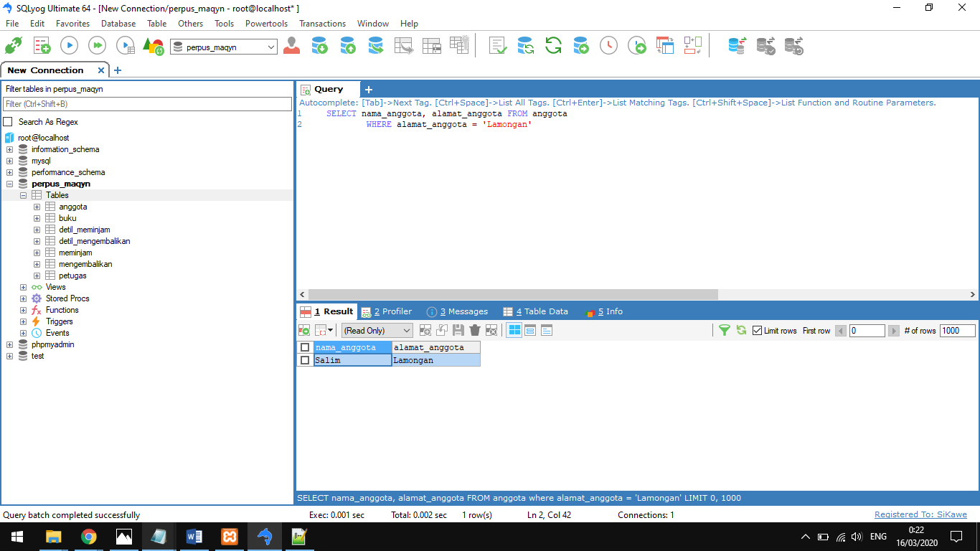

Query:

SELECT nama_petugas FROM petugas

WHERE alamat_petugas = 'Bangkalan'

Output:

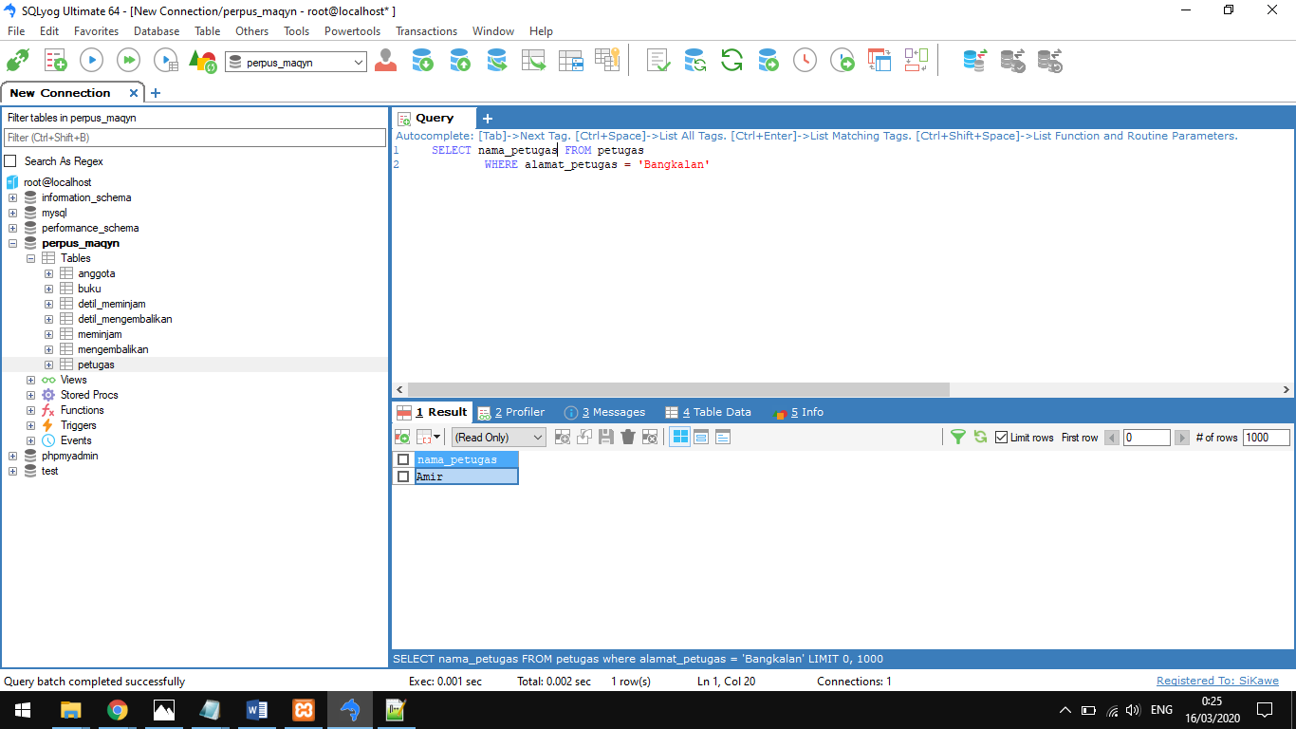

Query:

SELECT nama_petugas FROM petugas

WHERE id_petugas = '001'

Output:

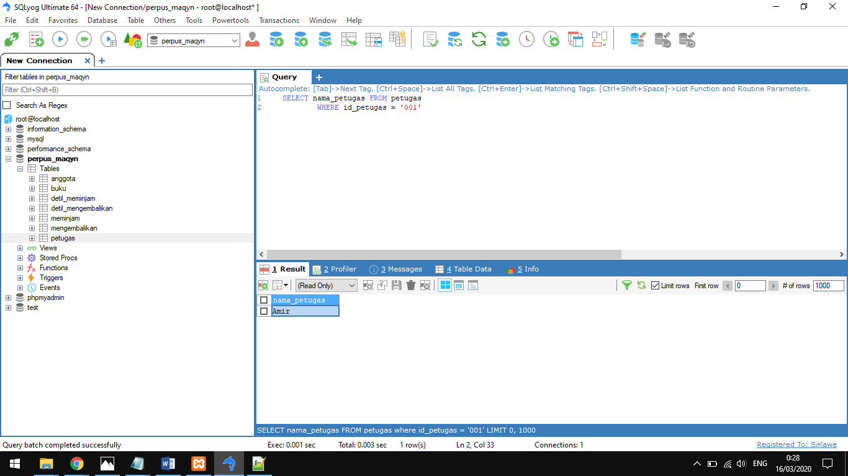

Daftar Pustaka

<http://zonaaeb.blogspot.com/2013/11/pranbas-pt9-normalisasi.html> (diakses pada 6 maret 2020 pukul 09.30 wib)

<https://inet613111053.wordpress.com/2012/11/22/basis-data-perpustakaa/> (diakses pada 6 maret 2020 pukul 09.30 wib)

<https://mafan.web.ugm.ac.id/database-perpustakaan/> (diakses pada 7 maret 2020 pukul 10.32 wib)

<https://www.slideshare.net/binamulia/analisis-dan-perancangan-basis-data-perpustakaan> (diakses pada 12 maret 2020 pukul 19.43 wib)